

COMP9900

Term 1, 2021

Information Technology Project

Project Report

**Project Title:** Chatbot

**Group Name:** 9900-W18A-OuterHeaven

**Submission Date:** 23-Apr-2021

|  |  |  |  |  |
| --- | --- | --- | --- | --- |
|  | **Name** | **Email** | **ZID** | **Role** |
| 1. | Pei Wang | [z3290805@ad.unsw.edu.au](mailto:z3290805@ad.unsw.edu.au) | z3290805 | Design & Developer |
| 2. | Sriram Murali | [z5232023@ad.unsw.edu.au](mailto:z5232023@ad.unsw.edu.au) | z5232023 | Scrum Master, Tester |
| 3. | Janvi Paresh Sheth | [z5251994@ad.unsw.edu.au](mailto:z5251994@ad.unsw.edu.au) | z5251994 | Design & Developer |
| 4. | Ziyang Geng | [z5192405@ad.unsw.edu.au](mailto:z5192405@ad.unsw.edu.au) | z5192405 | Design & Developer |
| 5. | Darshana Pritam Shah | [z5298610@ad.unsw.edu.au](mailto:z5298610@ad.unsw.edu.au) | z5298610 | Design & Developer |

**Tutor:** Rachid Hamadi

**Lecturer:** Iwan Budiman

Table of Contents

1. Background for the Project 3

2. Aim / Project Objectives 4

3. System Architecture 5

Interface/Presentation Layer: 6

Fulfilment/Business Layer: 6

A Flask-based Server: 6

Database Layer: 7

Infrastructure Layer: 7

4. Key Features and Interface 7

4.1. Web User Interface for Chatbot Interaction 9

4.2. Movie Recommendations 9

4.3. Auto-filling forms on behalf of the user 9

4.4. Virtual Collaboration 10

4.5. BI Module for Users and the Company 10

5. Third Party Tools and their Utility in the Project 10

5.1. Dialogflow 10

5.2. Datalab 10

5.3. Webhook 10

5.4. APIs 10

5.5. WIX Website Builder 10

6. Implementation Challenges 10

6.1. Recommendation Module Algorithm 10

6.2. TABLEAU Integration 10

6.3. Movie Scheduler and Chat Feature 10

7. Installation Instruction 11

7.1. Build 11

7.2. Set Up 11

7.3. Configure 11

7.4. Test 11

8. Project Management 11

8.1. Communication Plan 11

8.2. Sprint Schedule 11

8.3. Project Plan 11

9. References 12

# 1. Background for the Project

Recently, chatbots have started gaining momentum in helping businesses grow due to its various advantages. Chatbots have evolved from simple rule-based chatbots to advanced AI-based chatbots. Artificial intelligence and various machine learning algorithms are used to enhance the performance of chatbots. Chatbots are replacing jobs that require human interaction, for example, customer service agents.

Due to COVID-19, a lot of outlets have been closed which has impacted the communication between businesses and their customers. Chatbots would play an important role here in bridging this gap as the customers would be able to communicate with the businesses through the chatbots online. Movies are shifting from the traditional platforms (i.e., theatres) to online platforms which the viewers can access at any time from their laptops, TVs or even their smartphones. This shift has been further accelerated due to COVID-19.

With the help of chatbots, the digital media platforms can build and target a variety of new audience. Digital streaming platforms like Netflix can also make use of chatbots to boost sales opportunities. With the help of artificial intelligence, the income of users can be predicted based on their location, viewing history, device type, etc. so that the appropriate packages/upgrades can be presented to the appropriate users to ensure a guaranteed sale thereby generating a guaranteed profit. Chatbots can be modelled to analyze a user’s past behavior, learn about their preferences with the help of powerful machine learning algorithms and artificial intelligence. Through this, they can predict user behavior or make forecasts and thereby suggest movies and shows that the user is most likely to watch. They can also motivate users to continue watching content or redirect them to new content based on their preferences and behavior thereby promoting new content too.

Chatbots can also provide numerous services to viewers without any human intervention such as personalized content recommendations and quick suggestions which will save the time spent on navigating and browsing content. This will lead to an improved viewing experience for the users and increase engagement. They also provide an easy form of communication for the viewers. Chatbots can keep the users in loop by always being available and answering their queries irrespective of the time zones.

Furthermore, the digital media platforms in the entertainment industry can build their brand loyalty among their users by providing personalized treatments to them through chatbots. Usually there is limited customer support available online to assist the viewers and chatbots could be the solution. Offline 24/7 customer support is more expensive as the night shifts’ payments are slightly on the higher side than day shifts’ payments. Viewers tend to watch movies and shows in their free time which is generally after the working hours in the evening or at night. Due to higher expenses, companies generally do not invest in customer support that is available during these hours thereby causing communication issues. Chatbots help in solving these issues as they can work 24/7. They are also comparatively more efficient and less expensive.

Through our project, we aim to build an interactive AI-based chatbot that could solve these issues and provide the benefits listed above.

# 2. Aim / Project Objectives

1. To build a chatbot along with a knowledge extraction module based on the content and user behavior servicing an online content provider in the entertainment industry.
2. To build a dialog builder that leverages on existing APIs and keeps track of the contextual conversation between the user and the chatbot.
3. To build a web application to deploy the chatbot to a simple web chat.
4. To build a chat module with predefined set of questions based on the user FAQs in case the default module is unable to help the user with his/her objective.
5. To build a novel module that recommends content to the user based on their contacts’ and groups’ viewing history; this module will depend on the privacy settings of each user.
6. To build a module that will enable the chatbot to get instructions from the user and auto update various details such as liking and rating movies, shows, etc. in addition to auto populating webpages with user details and present it to the user for review and submission, such as payment processing for subscription updates thereby reducing the workload for users.
7. To build a novel module to enable the chatbot to organize a movie meeting with the user and the user's friends based on a simple ‘Yes/No’ response.
8. To build a module that will generate meaningful reports for the user and the company by analyzing user behavior patterns with the help of Business Intelligence (BI).

# 3. System Architecture

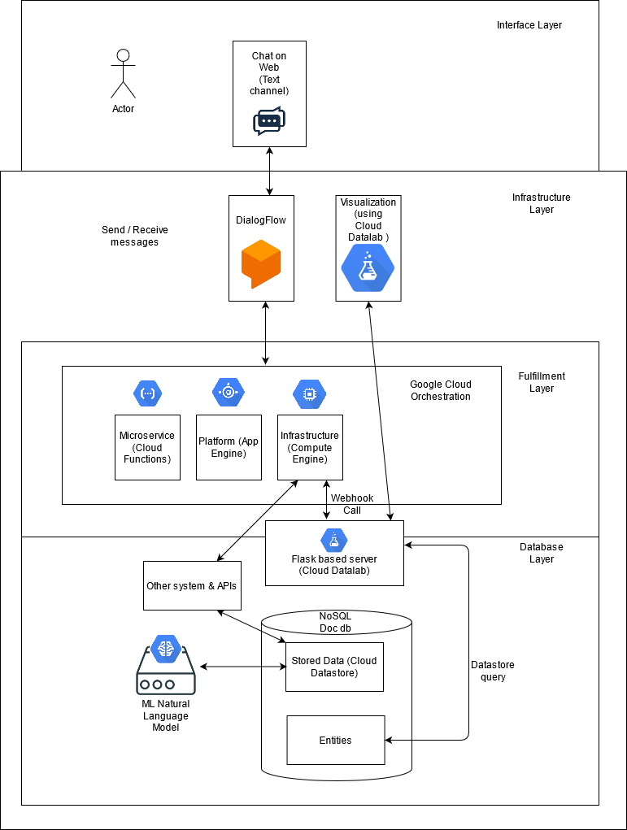

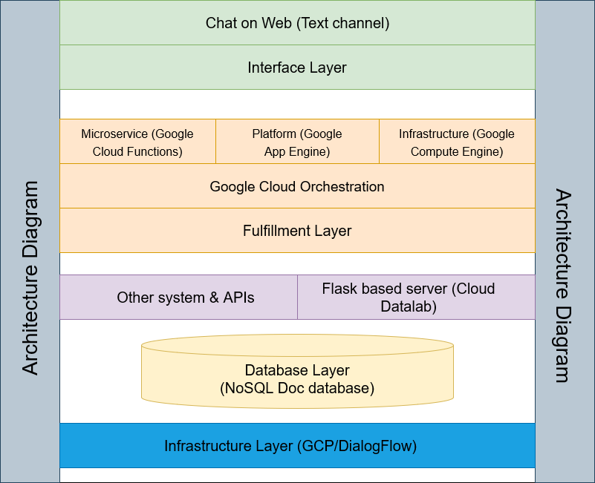

The system has the following components:

## Interface/Presentation Layer:

The conversational interface of this chatbot primarily uses the text format, but it can also accept voice commands. The user can chat on a web interface using natural and rich interactions.

## Fulfilment/Business Layer:

This layer is what connects the virtual agent to the external systems to access the backend such as the database, APIs, or other directories. It is used to fetch dynamic information to adhere to the user’s request and keeps the conversation flowing. The fulfilment layer used Google Cloud Orchestration, which contains Google Cloud Functions, Google App Engine, and Google Compute Engine. The Compute Engine is what helps connect to the infrastructure such as the APIs and database. The visualisations can be performed by using Google Cloud Datalab.

## A Flask-based Server:

For the compute engine to access the database a webhook call is sent to the Flask based server (that we build on Google Cloud Datalab) and that sends a datastore query to the database.

## Database Layer:

The data from APIs is pre-processed in Google Cloud Datalab to create topics and is then extracted, and its associated synonym is saved for each topic. The resulting entities are stored in Cloud Datastore. Once, the data is available in the Datastore, the Flask-based server continuously accepts requests from the Dialogflow Fulfilment API and responds by using the data stored in the Datastore.

## Infrastructure Layer:

The conversation is managed by Dialogflow, which is the main component of the interface as it enables the interaction using text and speech. The agent, which is created, using Dialogflow, manages the conversation flow based on the intent or intention extracted from the user conversation.

# 4. Key Features and Interface

The following images display what our chatbot would look like to a user once it's deployed on the web.

* The first image displays a scenario where the user wants to watch an action movie. The chatbot recommends some of the action movies that are popular or currently trending. The user specifies the year from which he wants to watch an action movie so the chatbot recommends some of the popular movies from that year.

* The second image displays a scenario where the user wants to update his account details and the chatbot redirects the user to that link.

* The third image displays a scenario where the user wants to set a date and time to watch a particular movie with his friend online. The chatbot confirms the date and time and sends a request to the user’s friend.

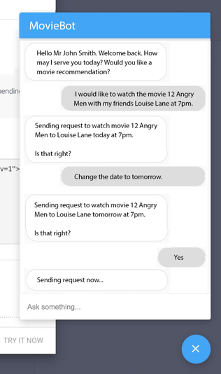

Some of our key features are explained below.

## 4.1. Web User Interface for Chatbot Interaction

This functionality will be the development of a UI or a web interface for a user to interact with the chatbot. User login will have an authentication and authorization mechanism to make sure “A user is valid – You are who you are, and you access what you are allowed to access”. Once authenticated, the chatbot will introduce itself to user and provide the user with some basic FAQs and present the user with relevant answers based on user choice. If the user is unable to get the necessary help with the FAQs, then the system will seamlessly transition to the smart chatbot.

## 4.2. Movie Recommendations

This will be a novel functionality wherein the chatbot will recommend entertainment options to a user not just based on the user behavior but also based on the activity of the user’s friends and groups.

Example: If a user is asking the chatbot to recommend a good period movie. The chatbot could respond with “Hello Mr. Jack, your friend Ms. Jill just watched Dunkirk and rated it 5 starts. It is not just a good period movie. It is EPIC. Would you like to know more about Dunkirk?”

Of course, this functionality will take into consideration all the users privacy settings.

## 4.3. Auto-filling forms on behalf of the user

This functionality will focus on assisting a user with simple online updates. This will be split into two – updates where in a user will have to authorize and submit, updates where in a user just needs to confirm.

* **User Confirmation Updates**

Example – User – “Can you please rate Dunkirk 3 stars?”

Chatbot – “Rating Dunkirk with 3 stars. Please confirm with response. Yes/No”

User – Yes

Chatbot – “Done. User rated Dunkirk with 3 stars. Anything else I can assist with?”

* **Auto filled forms for User Review and Submission**

Example – User – “Can you please upgrade my subscription to premium?”

Chatbot – “I am glad to know that you want to be a premium member with us. I have auto filled a few details for you. Please click the link, review the details and carefully check your plan and price before submitting and authorizing a payment process. Thank you.”

## 4.4. Virtual Collaboration

This is a novel functionality that we want to develop, and we think will have a great potential in the future. The user can ask the chatbot to organize a virtual movie meeting with some of his/her friends. The chatbot will then send out meeting invites and based on a simple Yes/No response from the user’s friends will organize a virtual movie meeting collaboration with the group of users at a specified team. This will mean a group of friends can virtually watch the same movie at the same time and talk / comment about it from the comfort of their own couches at their home.

## 4.5. BI Module for Users and the Company

We intend to develop this module to data mine and run analytics on user activity and generate meaningful reports beneficial to the user and company. Reports can specify a user how much time he/she spends on the platform and on what type of content. This can help users take decision on the current plan – weather to upgrade or downgrade etc.

Reports can also benefit the company to understand what the popular contents are and what they need to focus on to improve their customer base etc.

# 5. Third Party Tools and their Utility in the Project

## 5.1. Dialogflow

## 5.2. Datalab

## 5.3. Webhook

## 5.4. APIs

## 5.5. WIX Website Builder

# 6. Implementation Challenges

## 6.1. Recommendation Module Algorithm

## 6.2. TABLEAU Integration

## 6.3. Movie Scheduler and Chat Feature

# 7. Installation Instruction

## 7.1. Build

## 7.2. Set Up

## 7.3. Configure

## 7.4. Test

# 8. Project Management

## 8.1. Communication Plan

We ran a total of three Sprints and followed two weeks Sprint planning. Regular scrum meetings and catch up's were scheduled during the sprint to track project progress, remove roadblocks if any and keep pushing towards our objectives and final delivery. Meetings were held three times a week from 8:00 p.m. to 09:00 p.m. to showcase individual work, obtain feedback from others, and address blockers and plan for the next set of activities. We also conducted three sprint planning sessions and two retrospectives over the course of this project. We used WhatsApp and Microsoft Teams as our main communication platform. Blackboard collaborate sessions were used to communicate during the Lab weeks.

## 8.2. Sprint Schedule

We ran three Sprints over the course of this project.

**Week 1:** Introduction, Team Forming

**Week 2:** Selecting a topic for our project and research various design / architecture options

**Week 3:** Creation and submission of project proposal document, document requirements and create user stories

**Sprint 1 (Week 4-5):** Environment set up; establish connectivity, interfacing various layers and Demo 1

**Week 6:** Break week – so we don’t plan to run a Sprint; continued developing some features

**Sprint 2 (Week 7-8):** Software development, testing, bug fixes and Demo 2

**Sprint 3 (Week 9-10):** Testing, Bug fixes, Performance improvement, project report, user manual, software installation instructions documentation and final Demo

## 8.3. Project Plan

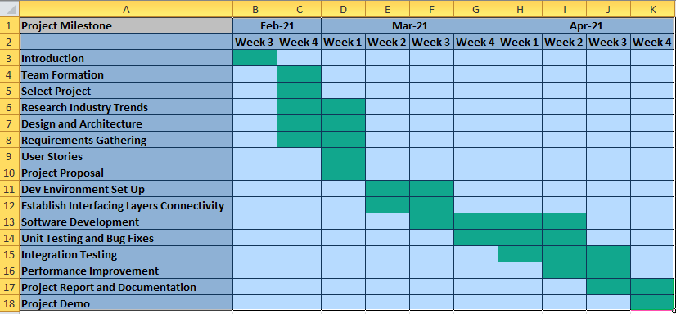

# 9. References

1. M. Kim, S. Jeon, H. Shin, W. Choi, H. Chung and Y. Nah, "Movie Recommendation based on User Similarity of Consumption Pattern Change," 2019 IEEE Second International Conference on Artificial Intelligence and Knowledge Engineering (AIKE), Sardinia, Italy, 2019, pp. 317-319, doi: 10.1109/AIKE.2019.00064.
2. A. F. Muhammad, D. Susanto, A. Alimudin, F. Adila, M. H. Assidiqi and S. Nabhan, "Developing English Conversation Chatbot Using Dialogflow," 2020 International Electronics Symposium (IES), Surabaya, Indonesia, 2020, pp. 468-475, doi: 10.1109/IES50839.2020.9231659.
3. What Netflix teaches us about using AI to create amazing customer experiences. (2019, February 04). Retrieved from <https://www.mycustomer.com/service/channels/what-netflix-teaches-us-about-using-ai-to-create-amazing-customer-experiences>
4. Amanda. (2019, October 04). AI bot online in the entertainment industry: Herobot platform. Retrieved from <https://herobot.app/messenger-chatbot/ai-bot-online-in-the-entertainment-industry/>
5. Ganguly, S. (2020, September 21). Examples of chatbots and AI in media and entertainment industry. Retrieved from <https://blog.kore.ai/examples-of-chatbots-and-ai-in-media-and-entertainment-industry>
6. Beyers, J. (2019, March 14). Advantages of Chatbot integration into entertainment industry. Retrieved from <https://chatbotslife.com/advantages-of-chatbot-integration-into-entertainment-industry-f62bfed3c003>
7. Chatbots for media and entertainment industry. (2020, December 22). Retrieved from <https://botcore.ai/media-and-entertainment-bots/>
8. Knight, C. (2020, January 08). The 2020 AI AND Chatbot landscape for sports, entertainment, and media. Retrieved from <https://thechatbot.net/2020-chatbot-sports/>
9. Conversational AI in media & ENTERTAINMENT: Artificial solutions. (2020, December 01). Retrieved from <https://www.artificial-solutions.com/conversational-ai-media-entertainment>